Cloud-AI Native Smartphone Intelligence Software

**1️⃣ AI & Machine Learning Intelligence Layer**

**Purpose: Core intelligence powering recommendations, predictions, and explanations.  
Clustered Features:**

1. **AI Persona Matching Engine**
   * **K-Means clustering, NLP quiz/chatbot input**
   * **Output: Persona → Recommended phones**
2. **A/B Performance Test Simulator (AI Lab)**
   * **Regression/XGBoost on specs + benchmarks**
   * **Output: Predicted frame rate/task time**
3. **Spec Forecasting for Upcoming Phones**
   * **LLM + Time-series + Confidence scoring**
   * **Output: Predicted future specs**
4. **Explainable AI (XAI) Recommendation Justification**
   * **SHAP/LIME → Human-readable reasoning**
   * **Output: “Why this phone?” insights**

**Development Dependencies:**

* **Python ML (scikit-learn, XGBoost, LSTM)**
* **NLP (spaCy, Hugging Face Transformers)**
* **Optional: GPT/Gemini API for explanation and forecasting**

**2️⃣ Marketplace & Data Intelligence Layer**

**Purpose: Real-time price, spec, and fraud monitoring.  
Clustered Features:**

1. **Live Marketplace Intelligence**
   * **Scrapy + LSTM for price/stock alerts**
   * **Firebase/MongoDB for storing historical trends**

**Development Dependencies:**

* **Scrapy/BeautifulSoup for scraping**
* **Firebase or MongoDB Atlas (free tier)**
* **Cloud Scheduler or Railway cron for automation**

**3️⃣ User Interaction & Engagement Layer**

**Purpose: Enhance user experience via personalization, gamification, and community features.  
Clustered Features:**

1. **Modular Need Builder (Dream Phone)**
   * **Constraint solver + feature ranking → best match**
   * **Optional integration with persona engine**
2. **Gamification for User Engagement**
   * **Points, badges, leaderboards → Stored in Firebase**
   * **Optional: Community polls & voting**
3. **Live Voice Query in Any Language (if possible)**
   * **API: Whisper API / Google Speech-to-Text free tier**
   * **Use Case: Hands-free phone search**
   * **Integration: Record voice → API → recognized query → real-time search**

**Development Dependencies:**

* **Frontend: React or Flask-HTML/CSS/JS**
* **Firebase for gamification & quiz storage**

**4️⃣ Cloud & DevOps Infrastructure Layer**

**Purpose:** Hosting, scaling, monitoring, and automation.  
**Clustered Features:**

1. **Cloud Hosting (Phase 1–2)**
   * Flask backend → Render / Railway
   * MongoDB Atlas / Firebase DB
2. **AI Model Hosting (Phase 3)**
   * Hugging Face Spaces or AWS Lambda endpoints
   * REST API for prediction & scoring
3. **Cloud Automation & Monitoring (Phase 4–5)**
   * Price scraping cronjobs → Firebase updates
   * Alerts → Twilio/SendGrid/FCM
   * Monitoring → UptimeRobot, Prometheus + Grafana
4. **Security Layer**
   * HTTPS (Render/Vercel auto-SSL)
   * Firebase Auth + Google reCAPTCHA

**5️⃣ Optional Advanced Layer: Kubernetes + Microservices (if possible)**

**Purpose:** Enterprise-ready, modular, and scalable deployment.  
**Clustered Features:**

1. **Microservices Breakdown**
   * Flask backend (API Gateway)
   * ML Inference service (model pods)
   * Chatbot service (Gemini/OpenAI interface)
   * Scraper CronJob pod
   * Alert/Notification service
2. **K8s Features to Leverage**
   * HPA for auto-scaling backend pods
   * CronJobs for scraping & retraining
   * ConfigMaps/Secrets for API keys
   * Ingress for routing traffic
   * Prometheus + Grafana for cluster monitoring

**Development Dependencies:**

* Docker + Docker Compose
* Minikube or GKE (Free tier)
* YAML manifests: deployment.yaml, service.yaml, cronjob.yaml

**📌 Suggested Development Flow**

1. **Week 1–2: Core Flask app + frontend (quiz, comparison, timeline UI)**
2. **Week 3–4: AI Persona Engine + DB integration + basic scrapers**
3. **Week 4–5: Live price tracking + notifications + gamification**
4. **Week 6–7: AI Lab simulation + Sentiment Analysis + Explainable AI**
5. **Week 7–8: Optional Kubernetes deployment + Live Voice Query + CI/CD setup**

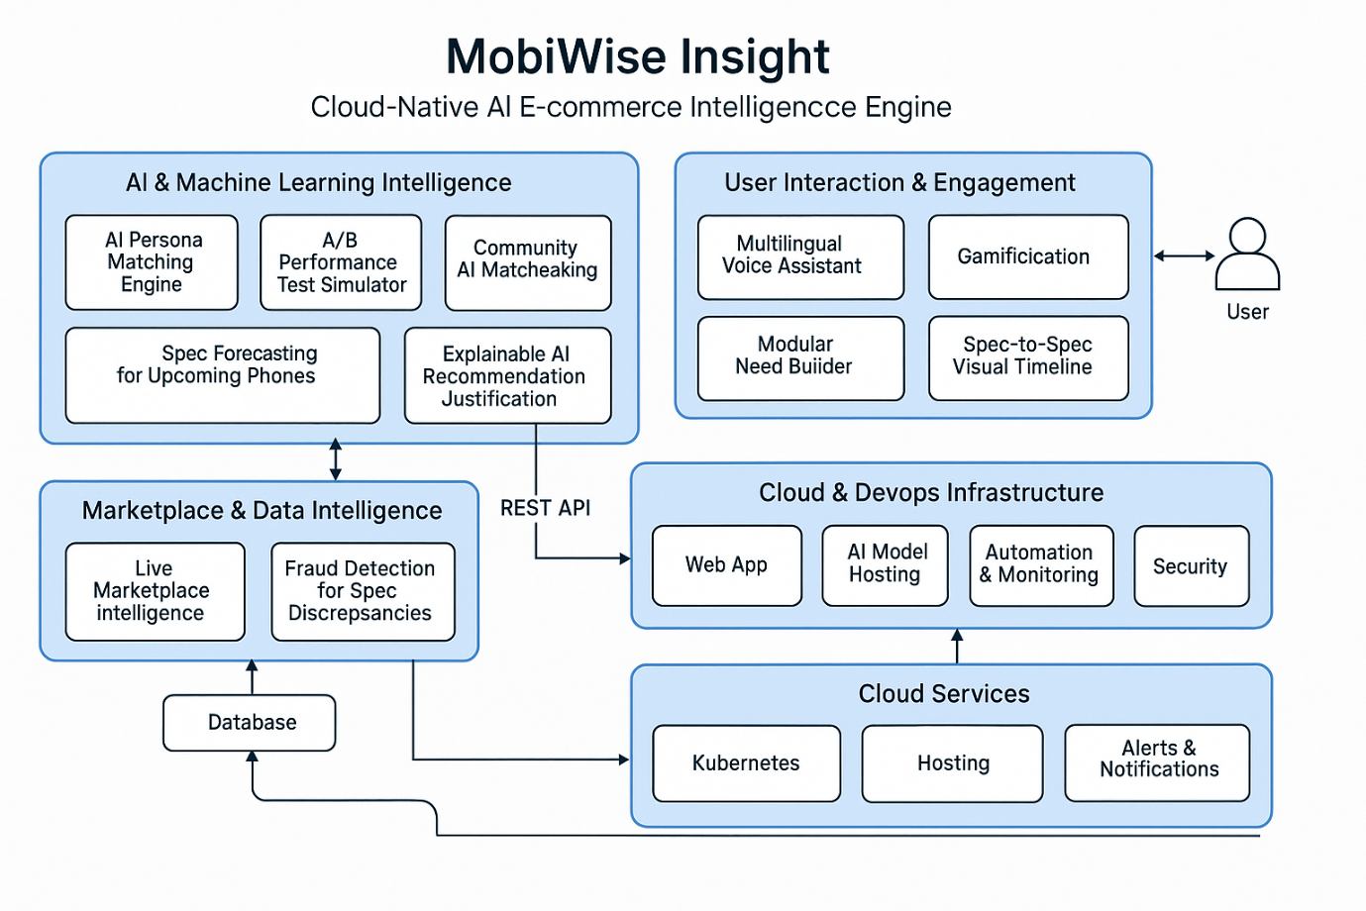

**CANSIS Modular Breakdown by Role**

**Module 1: AI/ML Intelligence & Data Engineering**

**Primary Role:**

* **ML Engineer / Data Scientist / Backend AI Developer**

**Responsibilities & Features:**

* **AI Persona Matching Engine (K-Means, NLP)**
* **A/B Performance Test Simulator (XGBoost, Regression)**
* **Spec Forecasting for Upcoming Phones (LLM, time-series)**
* **Explainable AI (SHAP/LIME, GPT/Gemini)**
* **Data pipeline: scraping, cleaning, storage**

**Key Dependencies:**

* **Python (scikit-learn, XGBoost, LSTM, pandas, numpy)**
* **NLP libraries (spaCy, Hugging Face Transformers, GPT/Gemini API)**
* **Scrapy, BeautifulSoup (for scraping)**
* **MongoDB Atlas or Firebase (for storing data)**
* **Cron jobs (Railway, Cloud Scheduler) for automation**

**Module 2: Application Backend & Cloud Infrastructure**

**Primary Role:**

* **Backend Developer / Cloud Engineer / DevOps**

**Responsibilities & Features:**

* **Flask/FastAPI backend (REST APIs for all AI/ML features, user data, notifications)**
* **Cloud DB integration (MongoDB/Firebase)**
* **AI Model hosting & serving (Hugging Face Spaces, AWS Lambda endpoints)**
* **Security Layer (Firebase Auth, Google reCAPTCHA, HTTPS)**
* **Automation: scraping scheduling, price/alert notification (Twilio/SendGrid)**
* **Monitoring: Prometheus, Grafana, UptimeRobot**
* **(Optional) Kubernetes orchestration (Docker, microservices, K8s YAML)**

**Key Dependencies:**

* **Python (Flask/FastAPI)**
* **MongoDB/Firebase Admin SDK**
* **Hugging Face, AWS Lambda (for model endpoints)**
* **Docker, Docker Compose (containerization)**
* **Kubernetes (Minikube/GKE, YAML manifests)**
* **Prometheus, Grafana (monitoring)**
* **Twilio, SendGrid, FCM (alerts)**
* **Railway/Render/Vercel (deployment)**

**Module 3: Frontend, User Interaction & Engagement**

**Primary Role:**

* **Frontend Developer / UX Designer / Community & Engagement Lead**

**Responsibilities & Features:**

* **User Interface (React, or Flask HTML/CSS/JS)**
* **Modular Need Builder (constraint solver UI, persona selection, dream phone builder)**
* **Gamification features (points, badges, polls, leaderboards)**
* **Community engagement (polls, feedback, matchmaking, live comparisons)**
* **Live voice query (Whisper API, Google Speech-to-Text integration)**

**Key Dependencies:**

* **ReactJS or Flask-HTML/CSS/JS**
* **Firebase (for quiz, gamification, user points)**
* **REST API clients (to interact with backend)**
* **Whisper API or Google STT (voice)**
* **Chart.js or similar (visualization)**
* **CSS frameworks (Bootstrap, Tailwind, optional)**

**CANSIS Target Users**

**CANSIS** (Cloud-AI Native Smartphone Intelligence Software) is designed for the following primary user groups:

1. **Smartphone Buyers & Upgraders**
   * Individuals looking to purchase a new smartphone or upgrade their current device
   * Users who want AI-powered, unbiased recommendations based on their needs, budget, and usage persona
2. **Tech Enthusiasts & Power Users**
   * Users interested in in-depth device analysis, benchmarks, future spec forecasting, and performance simulations
   * Community members who value transparent, explainable AI recommendations and want to explore "why" behind every suggestion
3. **Bargain Hunters & Price Trackers**
   * Users who wish to monitor real-time prices, receive alerts on price drops, stock changes, or exclusive offers across multiple marketplaces
4. **Community & Gamification Seekers**
   * Individuals who enjoy participating in tech communities, polls, discussions, and earning badges or rewards for engagement
5. **Multilingual & Accessibility-focused Users**
   * Users who prefer to interact in their native language or need voice-based hands-free search and navigation
6. **Non-Tech-Savvy Users**
   * People seeking a simple, intuitive interface for making confident, informed smartphone buying decisions—without needing technical knowledge

**Secondary Users**

* **Retailers and E-Commerce Professionals**  
  For competitive analysis, market trends, and customer engagement insights.
* **AI & Data Science Researchers**  
  For benchmarking, AI explanation, and dataset access.